**Programming Fundamentals**

**Lab Report**

**Lab 08**



|  |  |
| --- | --- |
| Group Members Name & Reg #: | **Muhammad Haris Irfan**  **(FA18-BCE-090)** |
|  |  |
| Class | Programming Fundamentals CSC103 (**BCE-2B**) |
| Instructor’s Name | Dilshad Sabir |

**In Lab Tasks**

**Question no: 1**

For the given program find (and print) the addresses assigned to all the variables against their names.

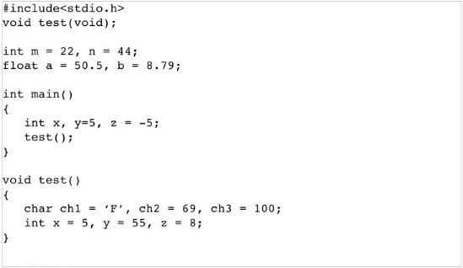

**Solution:**

The Code for the following code is attached below,

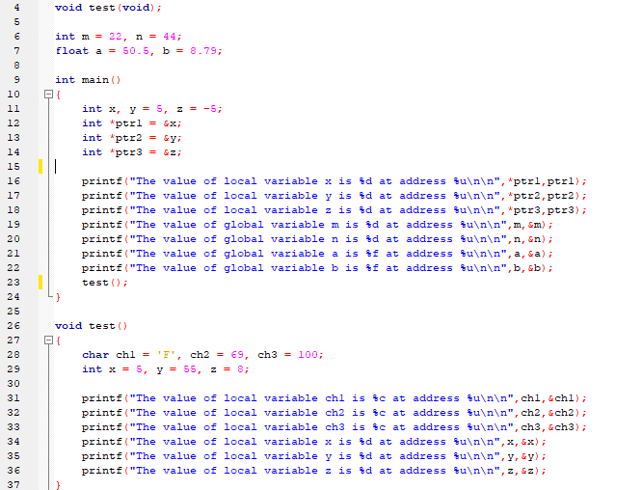

The Result of the following code is attached below:

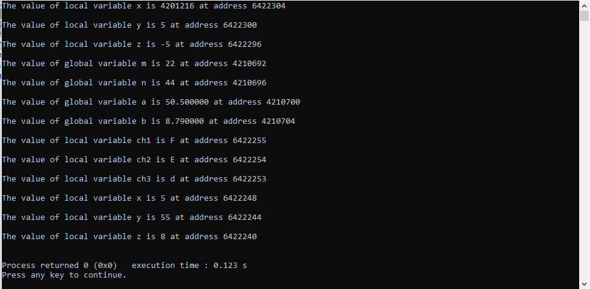

-------------------------------

**Question no: 2**

Write a C function which takes three integer inputs, corresponding to RGB components of a colored pixel, and coverts them to the YUV color space. The function should have the following prototype.

**void rgb2ycbcr**(int r, int g, int b, float * y, float * Cr, float * Cb);

Solution

The code added in main.c file is shown below.

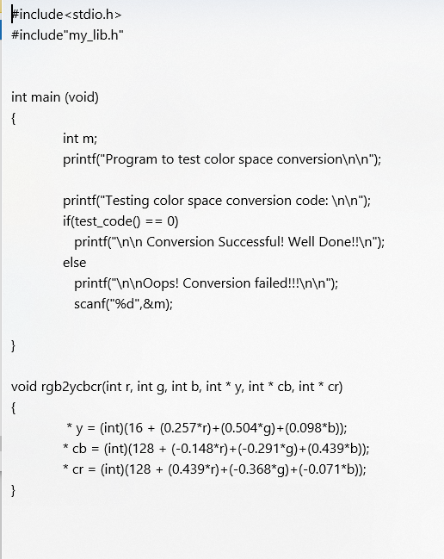

After adding this code, we saved the main.c file and generated a executable file for main.c file named main.exe, the result of main.exe is attached below.

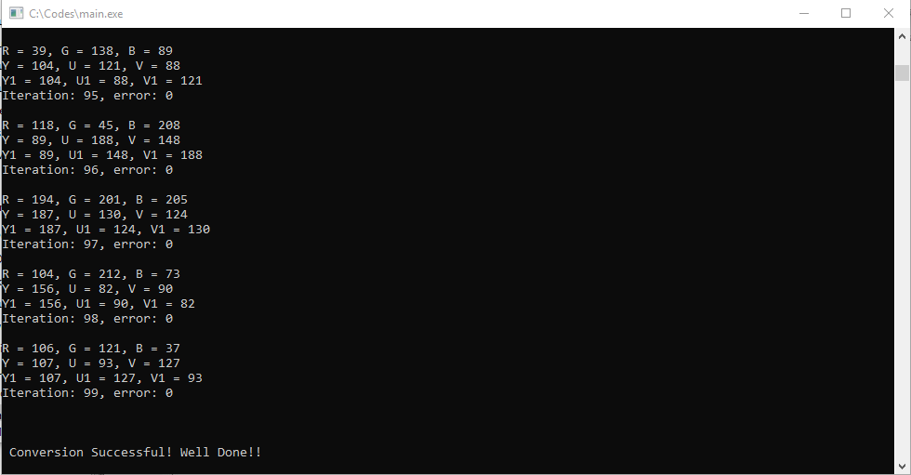

------------------------------

**Post Lab Task**

**Question:**

Write a recursive version of the Fibonacci function developed in class.

**Solution**

The code for this program is attached below,

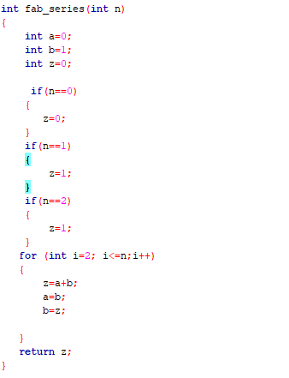

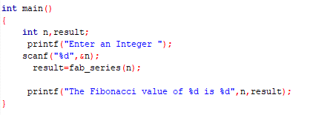

The Result of this program is attached below,

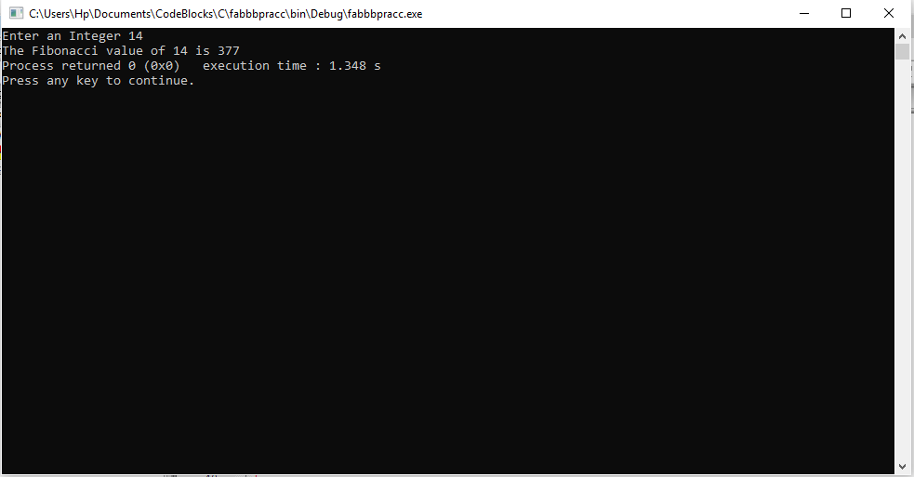

This result verifies that our code is correct as the Fibonacci value for integer 14 is 377.

------------------------------

THE END